**Tomcat installation in Redhat**

yum install java-1.8.0-openjdk-devel

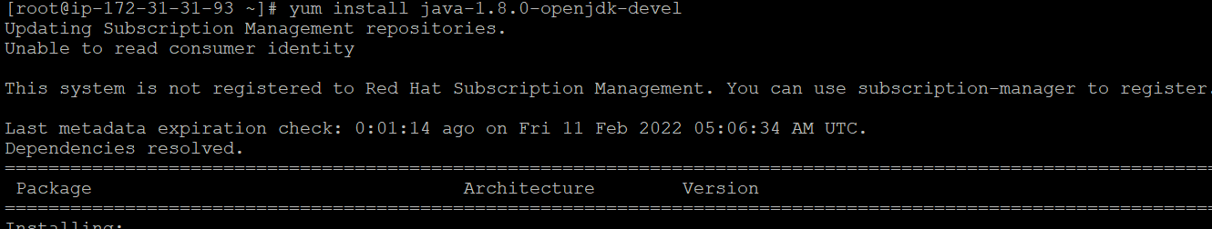

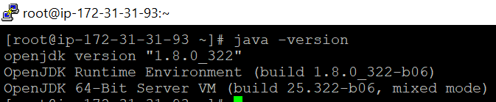

wget https://mirrors.estointernet.in/apache/tomcat/tomcat-9/v9.0.58/bin/apache-tomcat-9.0.58.tar.gz

